Fourth Sunday of Lent
-Temperance

OLOL Chapter

Weekly Newsletter

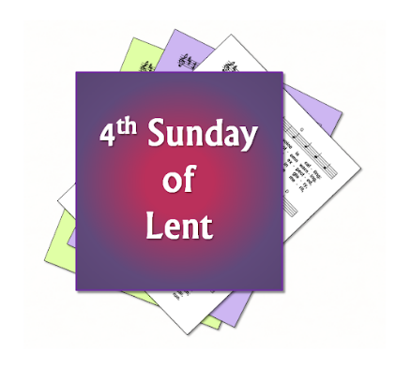
This week, we continue our study on the virtue of Temperance. Consider this from Fidelis, If a person lacks temperance, his mind becomes darker and self-focused. By good works, like almsgiving, one “lives the truth” and “comes to the light.” Therefore…the temperate woman gives alms.

Invitation: Your invitation this week is to join in any outreach efforts to the poor that are sponsored or organized by your parish. Make sure to ask your parents and the coordinators how you can serve the poor in your parish. If possible, make a donation to this mission from your own money.

Upcoming Schedule:
Monday, March 12 – meeting
King’s Message will be given by Jordan
Dinner provided by: Amy Klien & Kendra Altepeter
Dinner on 3/19: Angela Baum & Giuliana Bricker
Dinner on 4/2: Jennifer Clemens & Hilda Robles
Dinner on 4/9: Kerry Hartley & Katrina Henderson
For questions about providing dinner, please contact Ashley Sabo by text @ 615-812-6768.

MARK YOUR CALENDARS:
Friday, March 16th– Movie Night:
showing Princess Diaries 2
Saturday, March 17th – St. Patrick’s Day
Monday, March 19th - St. Joseph’s Feast Day
Sunday, March 25th – Palm Sunday
Monday, March 26th – Spring Break
Friday, March 30th – Good Friday
Sunday, April 1st - Easter
Fidelis Outing in April -TBD
Fidelis Ceremony on May 7th with Potluck dinner

